車子，還是杯子？

Car or Cup?

在這個專案裡，你要做一個能夠自動學習如何分類照片的Scratch專案。

In this project you will make a Scratch project that learns to sort photos.

教室裡的同學要一起合作訓練電腦，讓電腦有能力可以將一堆照片分成兩疊：

* 一疊車子的照片，以及
* 一疊杯子的照片

Your class will work together to train the computer to be able to sort a set of photos into two piles:

* one pile of photos of cars, and

* one pile of photos of cups



This project worksheet is licensed under a Creative Commons Attribution Non-Commercial Share-Alike License



http://creativecommons.org/licenses/by-nc-sa/4.0/

**教師教學指南：事前準備**

**Teacher / Group leader instructions : Setup**

這個版本的“車子，還是杯子？”活動會讓你的學生一起合作訓練一個單一機器學習模型。如果你需要可以讓學生單獨操作訓練模型的版本，可以從此處下載：<https://machinelearningforkids.co.uk/worksheets>

This version of the “Car or Cup” activity will get your class to work together to train a single machine learning model. A version of this activity where students can work individually to each train their own machine learning can be downloaded from <https://machinelearningforkids.co.uk/worksheets>

**目標：建立小組專案與課前準備**

**Objective:** Create a group project & prepare it for use by your class

1. 搜尋網頁：<https://machinelearningforkids.co.uk/>

Go to <https://machinelearningforkids.co.uk/> in a web browser

1. 使用教師帳號登入

Login using your teacher username/password

1. 點選上方清單中的 ”**Projects**” 按鈕

Click on “**Projects**” in the top menu bar

1. 點選 “**+ Add a new project**” 按鈕

Click on the “**+ Add a new project**” button

1. 建立一個專案，命名成 “Car or Cup”。設定辨識 “**images**”類別，並確認已勾選“**Whole-class project**”

Create a project called “Car or Cup”, set to recognise “**images**” and make sure you tick the “**Whole-class project**” checkbox  
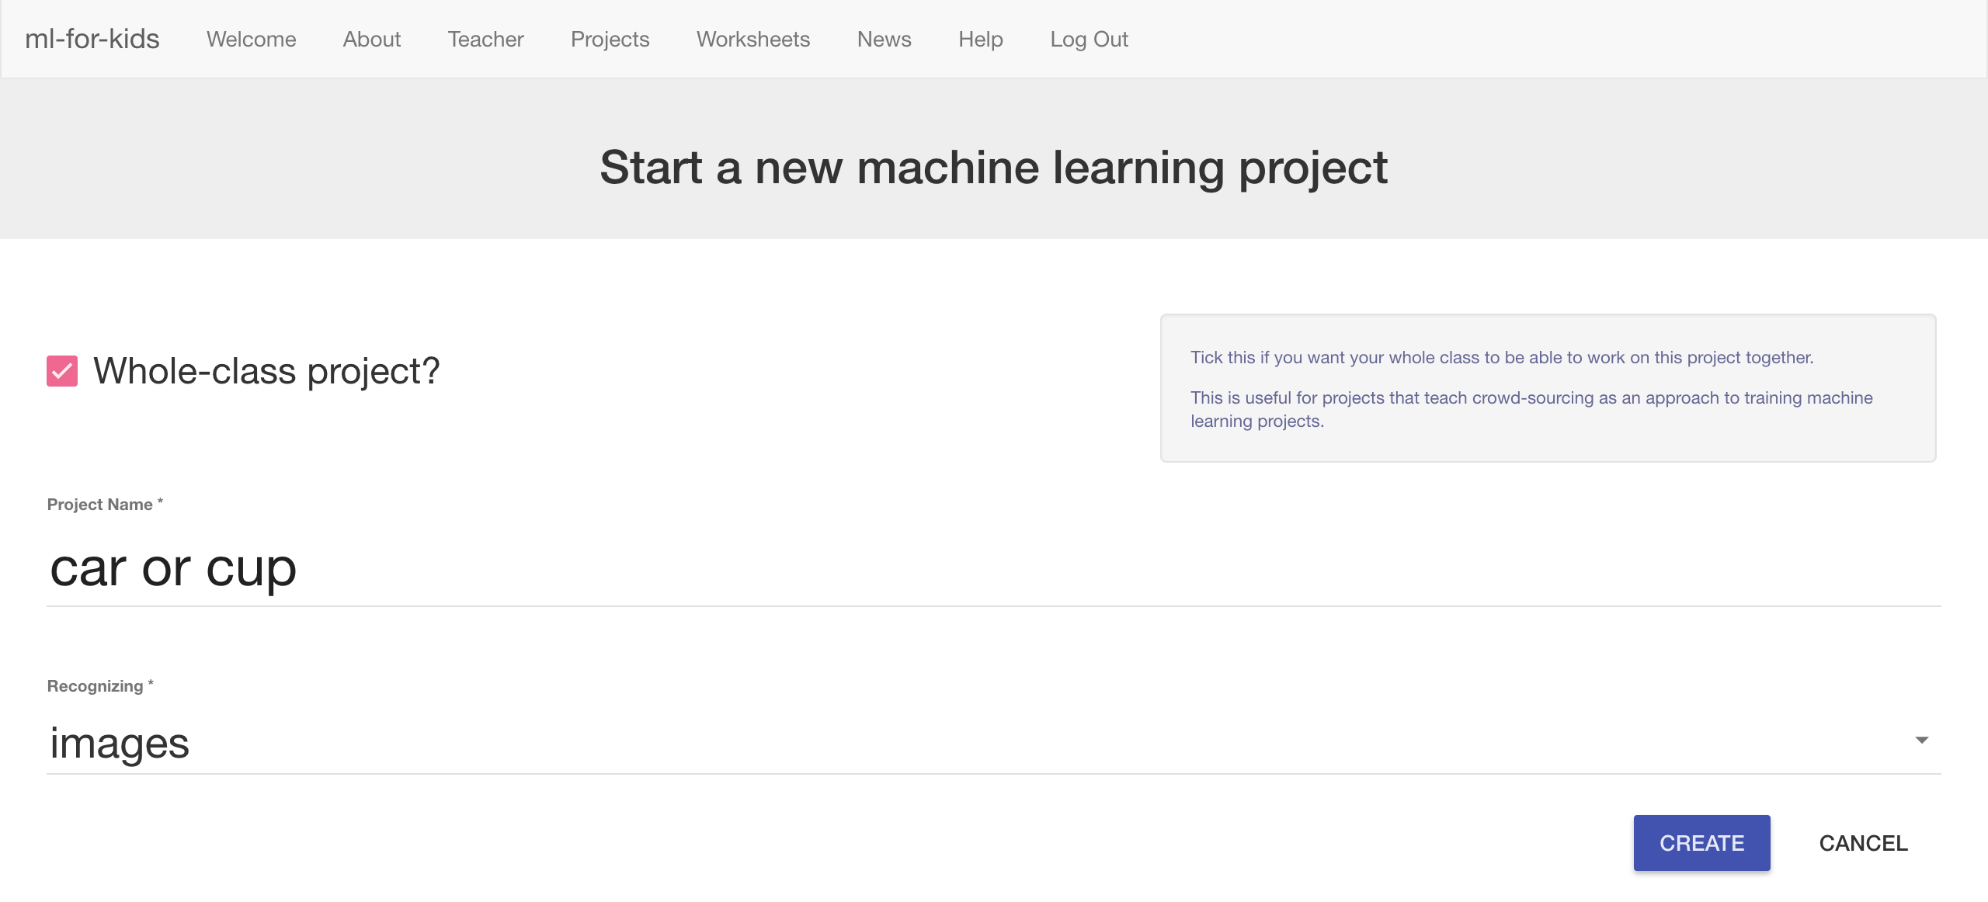

1. 點選 “**Create**” 按鈕

Click “**Create**”

1. 點選專案“Car or Cup”，再點選 “**Train**” 按鈕

Click on the “Car or Cup” project in the list, and then click “**Train**”

1. 點選“**+ Add new label**”按鈕來新增車子和杯子的分類訓練框

Use the “**+ Add new label**” button to create training buckets for Car and Cup  
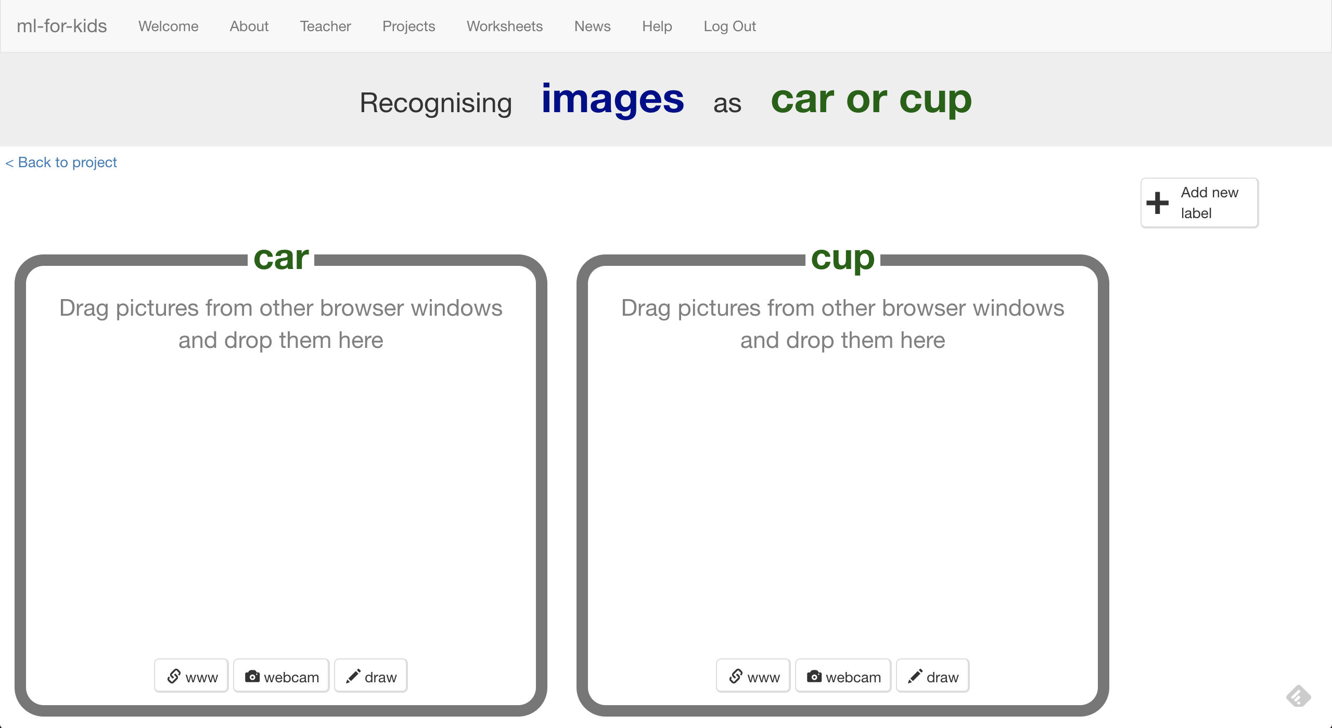

**給學生：實作步驟**

**Student instructions**

1. 搜尋網頁：<https://machinelearningforkids.co.uk/>

Go to <https://machinelearningforkids.co.uk/> in a web browser

1. 點選 “**Create**” 按鈕

Click on “**Get started**”

1. 點選“**Log In**”按鈕並登入系統

Click on “**Log In**” and type in your username and password

*如果你沒有帳號，請你的老師幫你建立一個帳號。*

*如果你不記得你的帳號或密碼，請你的老師幫你重新設定一次。*

*If you don’t have a username, ask your teacher or group leader to create one for you.  
If you can’t remember your username or password, ask your teacher or group leader to reset it for you.*

1. 點選上方清單中的 ”**Projects**” 按鈕

Click on “**Projects**” on the top menu bar

1. 你應該會看一個專案叫“car or cup”，點選此專案

You should see a “car or cup” project created by your teacher.   
Click on it.   
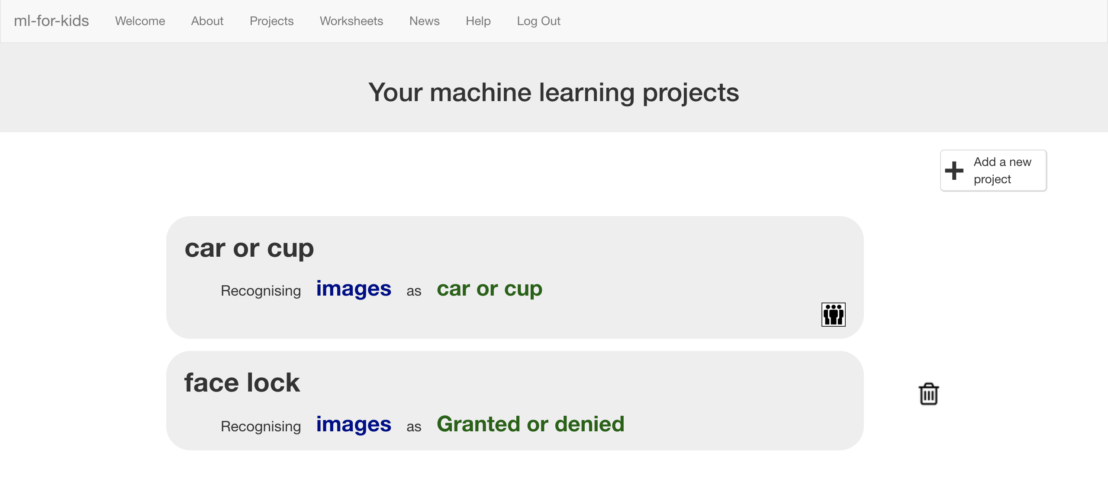

1. 點選“**Train**”按鈕開始搜集要訓練電腦用的範例照片

Click the “**Train**” button to start collecting examples of photos to train the computer with.

1. 你的老師已經幫你準備好照片的分類訓練框了Your teacher has prepared training buckets for pictures.   
   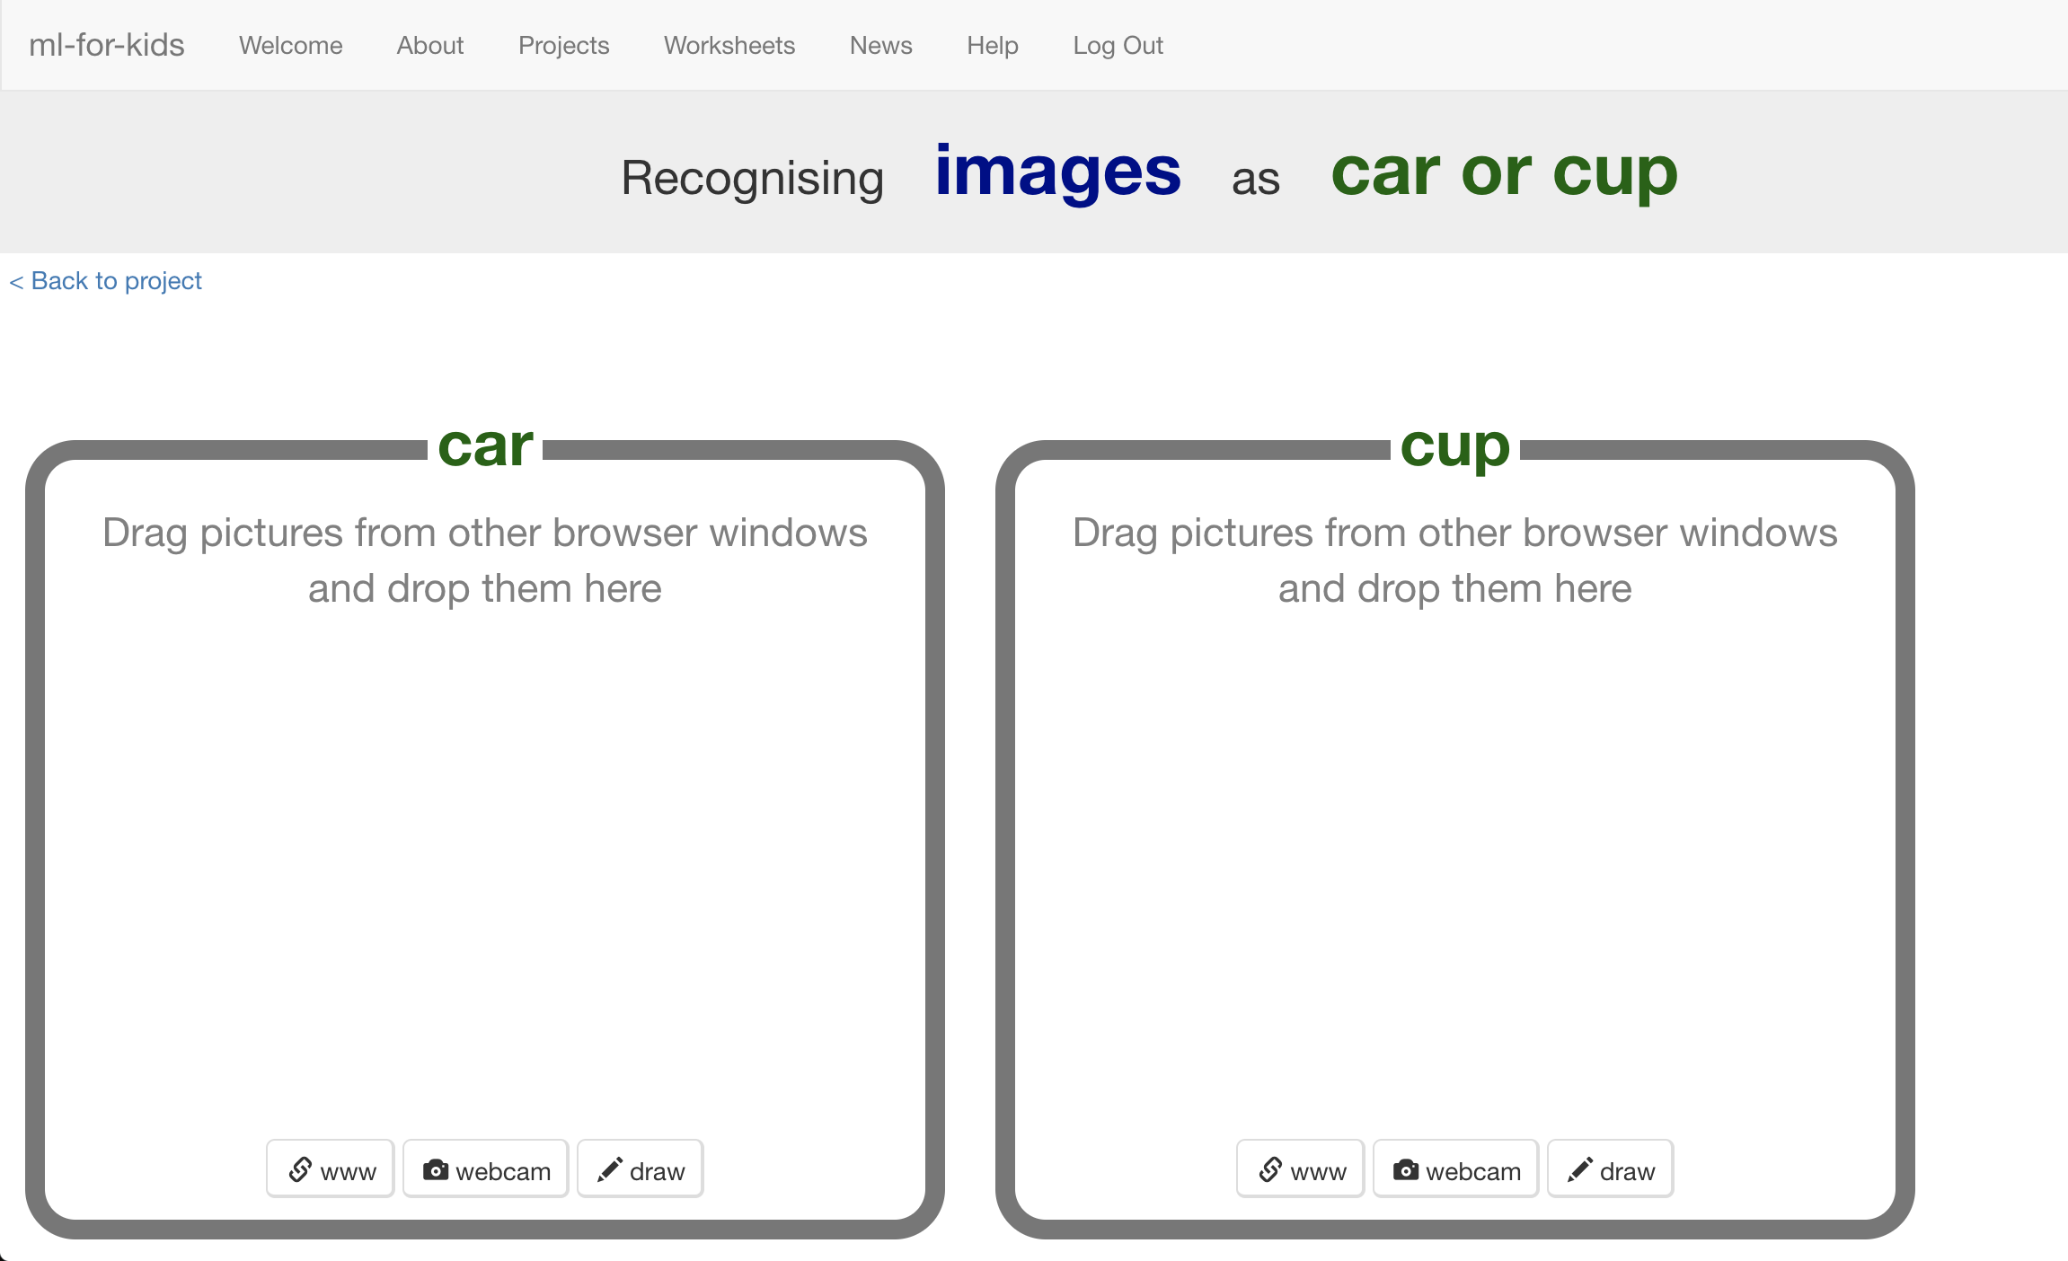

1. 開啟另一個網頁瀏覽器~~視窗~~Open another web browser window.
2. 調整兩個視窗大小（如下圖）Arrange the web browser windows so that they are side by side.  
   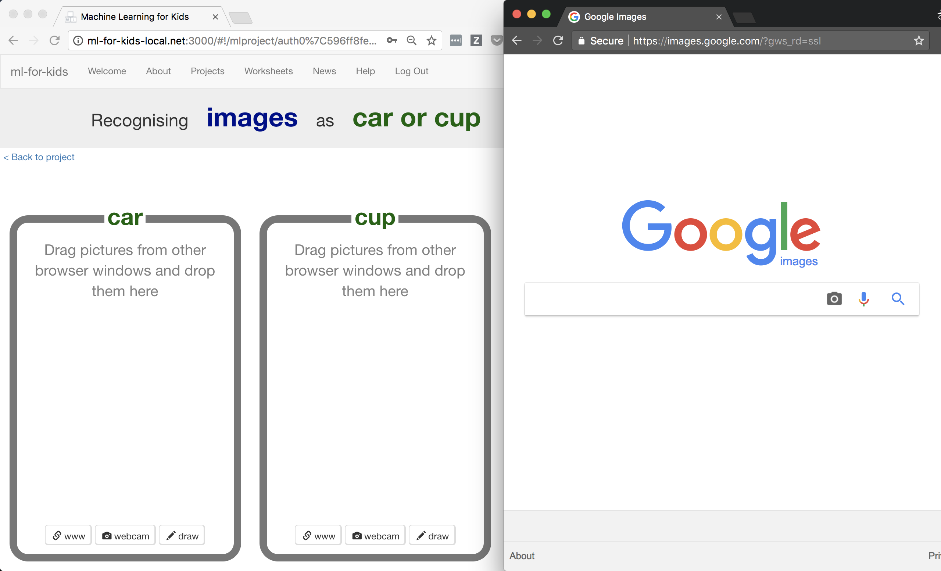
3. 在新的視窗中搜尋車子的照片。並將較佳的範例圖片拖曳至原先視窗中的左邊框框裡

In the new browser window, search for pictures of cars.   
Drag pictures that are good examples of a car into the left bucket.   
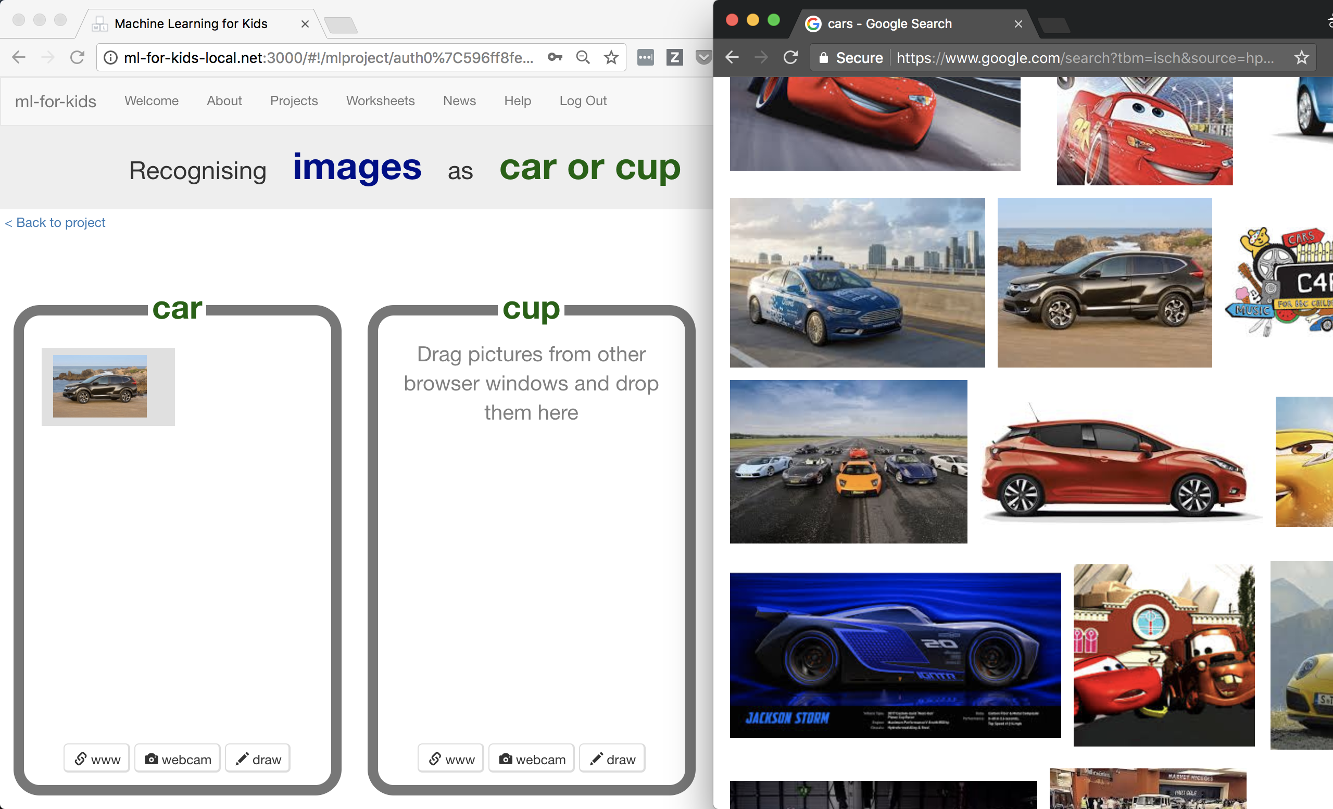

1. 重複上個步驟直到你搜集了一些車子圖片Repeat until you’ve collected a few examples of car photos.
2. 在新的視窗中搜尋杯子的照片。並將較佳的範例圖片拖曳至原先視窗中的右邊框框裡

Search for pictures of cups.   
Drag pictures that are good examples of a cup into the right bucket.   
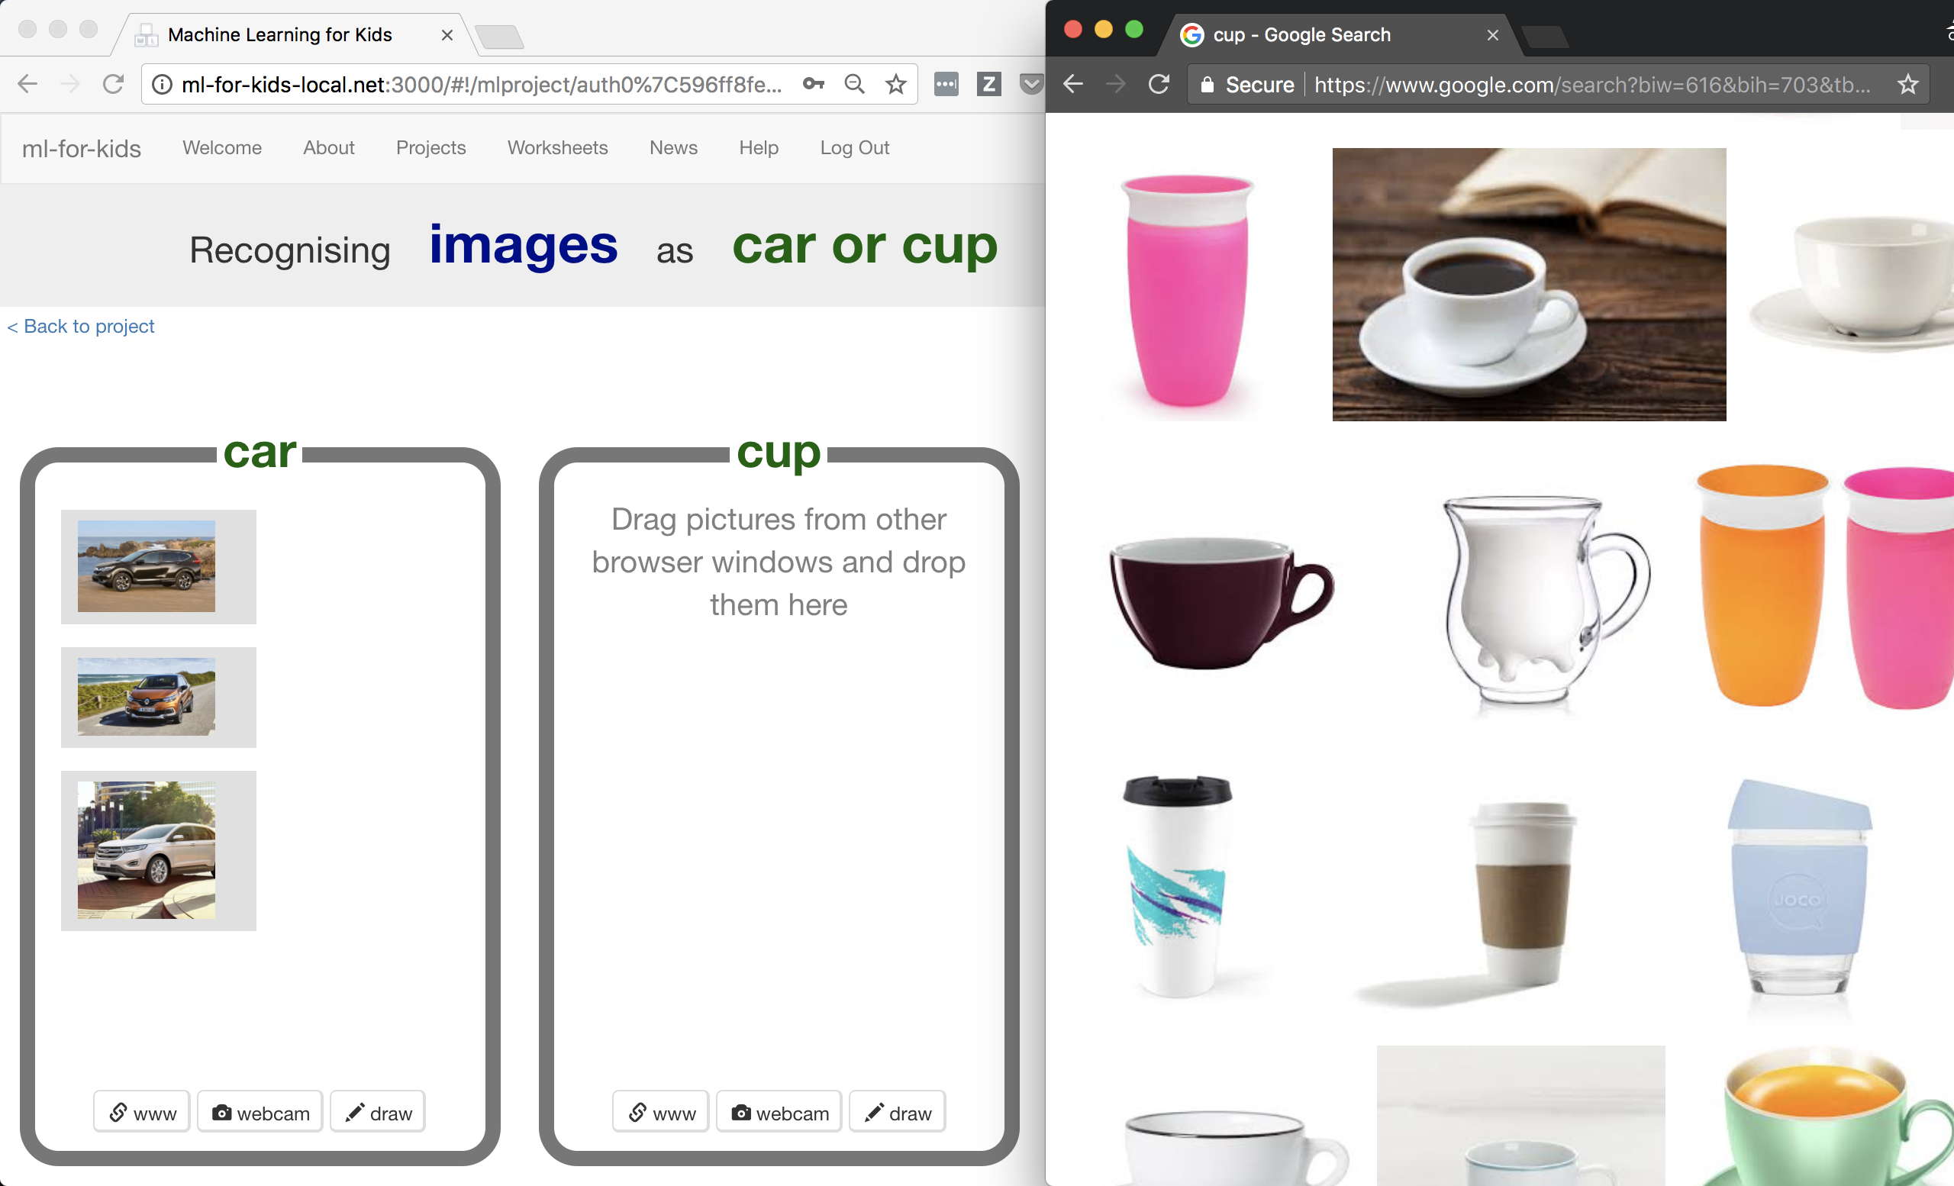

1. 重複上個步驟直到你搜集了一些杯子圖片Repeat until you have collected a few examples of cup photos.   
   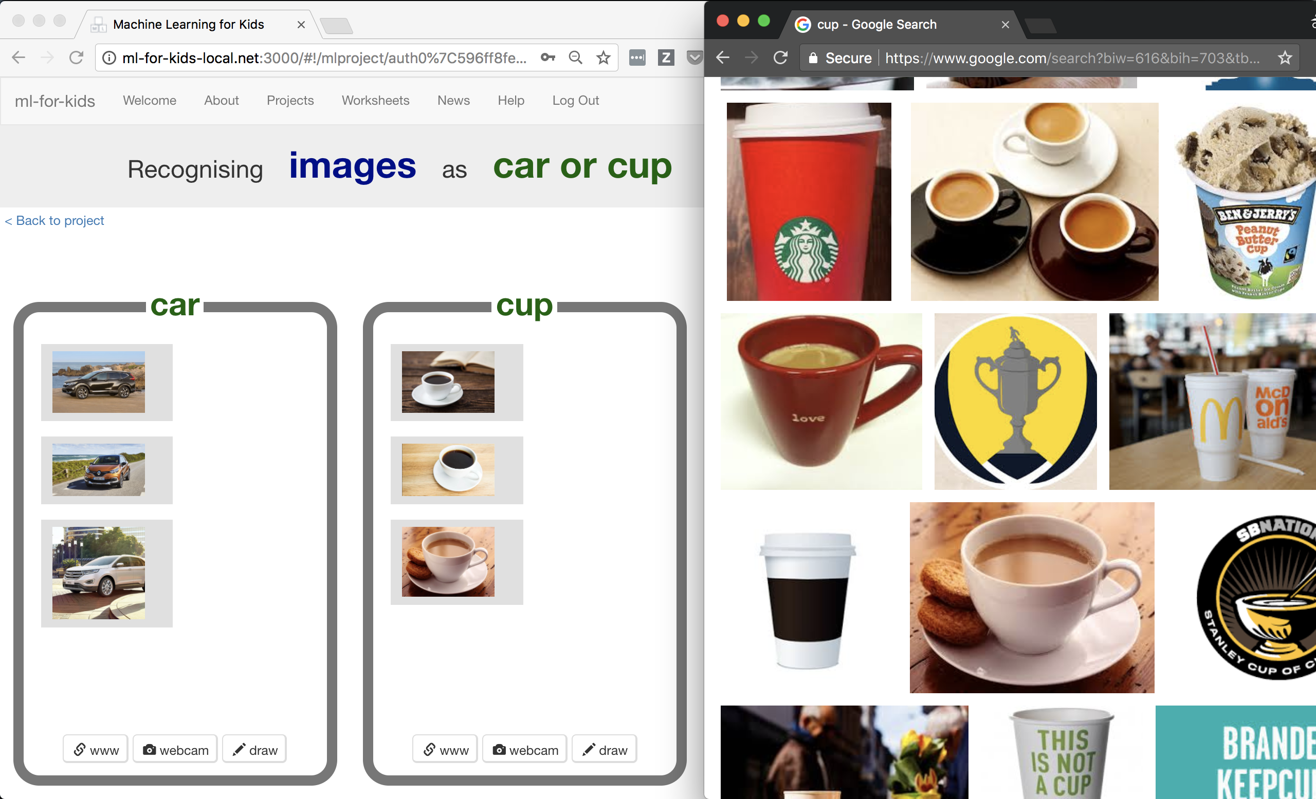

1. 你的同學也會把照片加進同一個訓練框裡，但你在此時並不會看到他們所搜集的照片。*重新整理頁面以看到全班所蒐集到的所有圖片*

Your classmates will also be adding photos to the same training buckets as you, but they won’t show up while you’ve got the page open.  
*Refresh the page to see all the training so far from the whole class.*

1. 重複上述步驟，直到你們班搜集到足夠的範例照片。**除非老師跟你們說可以繼續下個步驟，否則請繼續搜集照片**

Keep going until your class have collected enough examples.  
**Don’t move past this step until your teacher tells you that it is time to move on.**

**教師教學指南：訓練一個機器學習模型**

**Teacher / Group leader instructions : Train a ML model**

**目標：掌握班級進度，以及訓練一個機器學習模型**

**Objective:** Monitor class progress & train a machine learning model

1. 點選上方清單中的 ”**Projects**” 按鈕

Click on “**Projects**” in the top menu bar

1. 點選專案 “car or cup”

Click on the “car or cup” project

1. 點選“Learn & Test” 按鈕

Click on the “Learn & Test” button

1. 檢閱班級進度

*如果搜集的範例照片數量越多，模型應該會表現得越好。但一個模型至少各自需要10個範例才能建立*

Review the summary of the progress the class has made  
*The more examples they collect, the better the model should perform, but they need at least ten examples of each to be able to create a model at all.*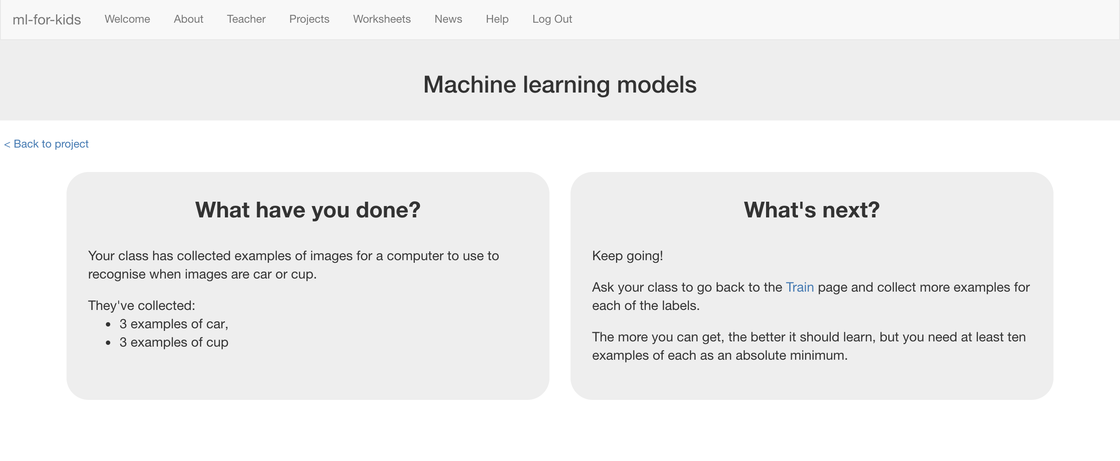

1. 如果你已經準備好繼續，點選 “Train new machine learning model”按鈕來使用這些範例照片訓練一個新的模型

*這可能會花費一到兩分鐘，當完成時，網頁上的狀態會從“Training”變為“Active”*

When you’re ready to proceed, click “Train new machine learning model” to train a new model using their examples.  
*This may take a minute or two. The status on the page will change from “Training” to “Active” once it has finished.*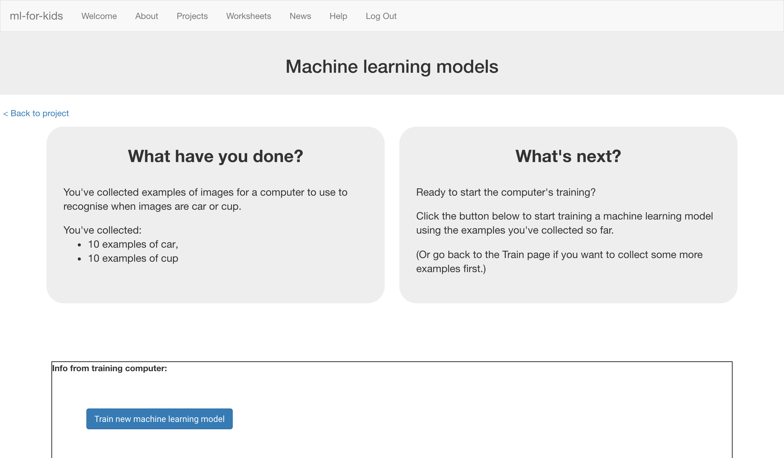

1. 當一切就緒後，你可以告訴學生繼續之後的動作

Once it is ready, you can tell the class it’s time to move on.

**給學生：實作步驟**

**Student instructions**

1. 點選“**< Back to project**”按鈕

Click the “**< Back to project**” link.

1. 你的老師已經使用你們所蒐集到的範例照片建立了一個機器學習模型

Your teacher has used the examples your class collected to train a machine learning model.

1. 點選“**Make**”按鈕，再點選“**Scratch**”按鈕

*此頁有如何使用Scratch新積木的教學*

Click the “**Make**” button, then the “**Scratch**” button.   
*This page has instructions on how to use the new blocks in Scratch.*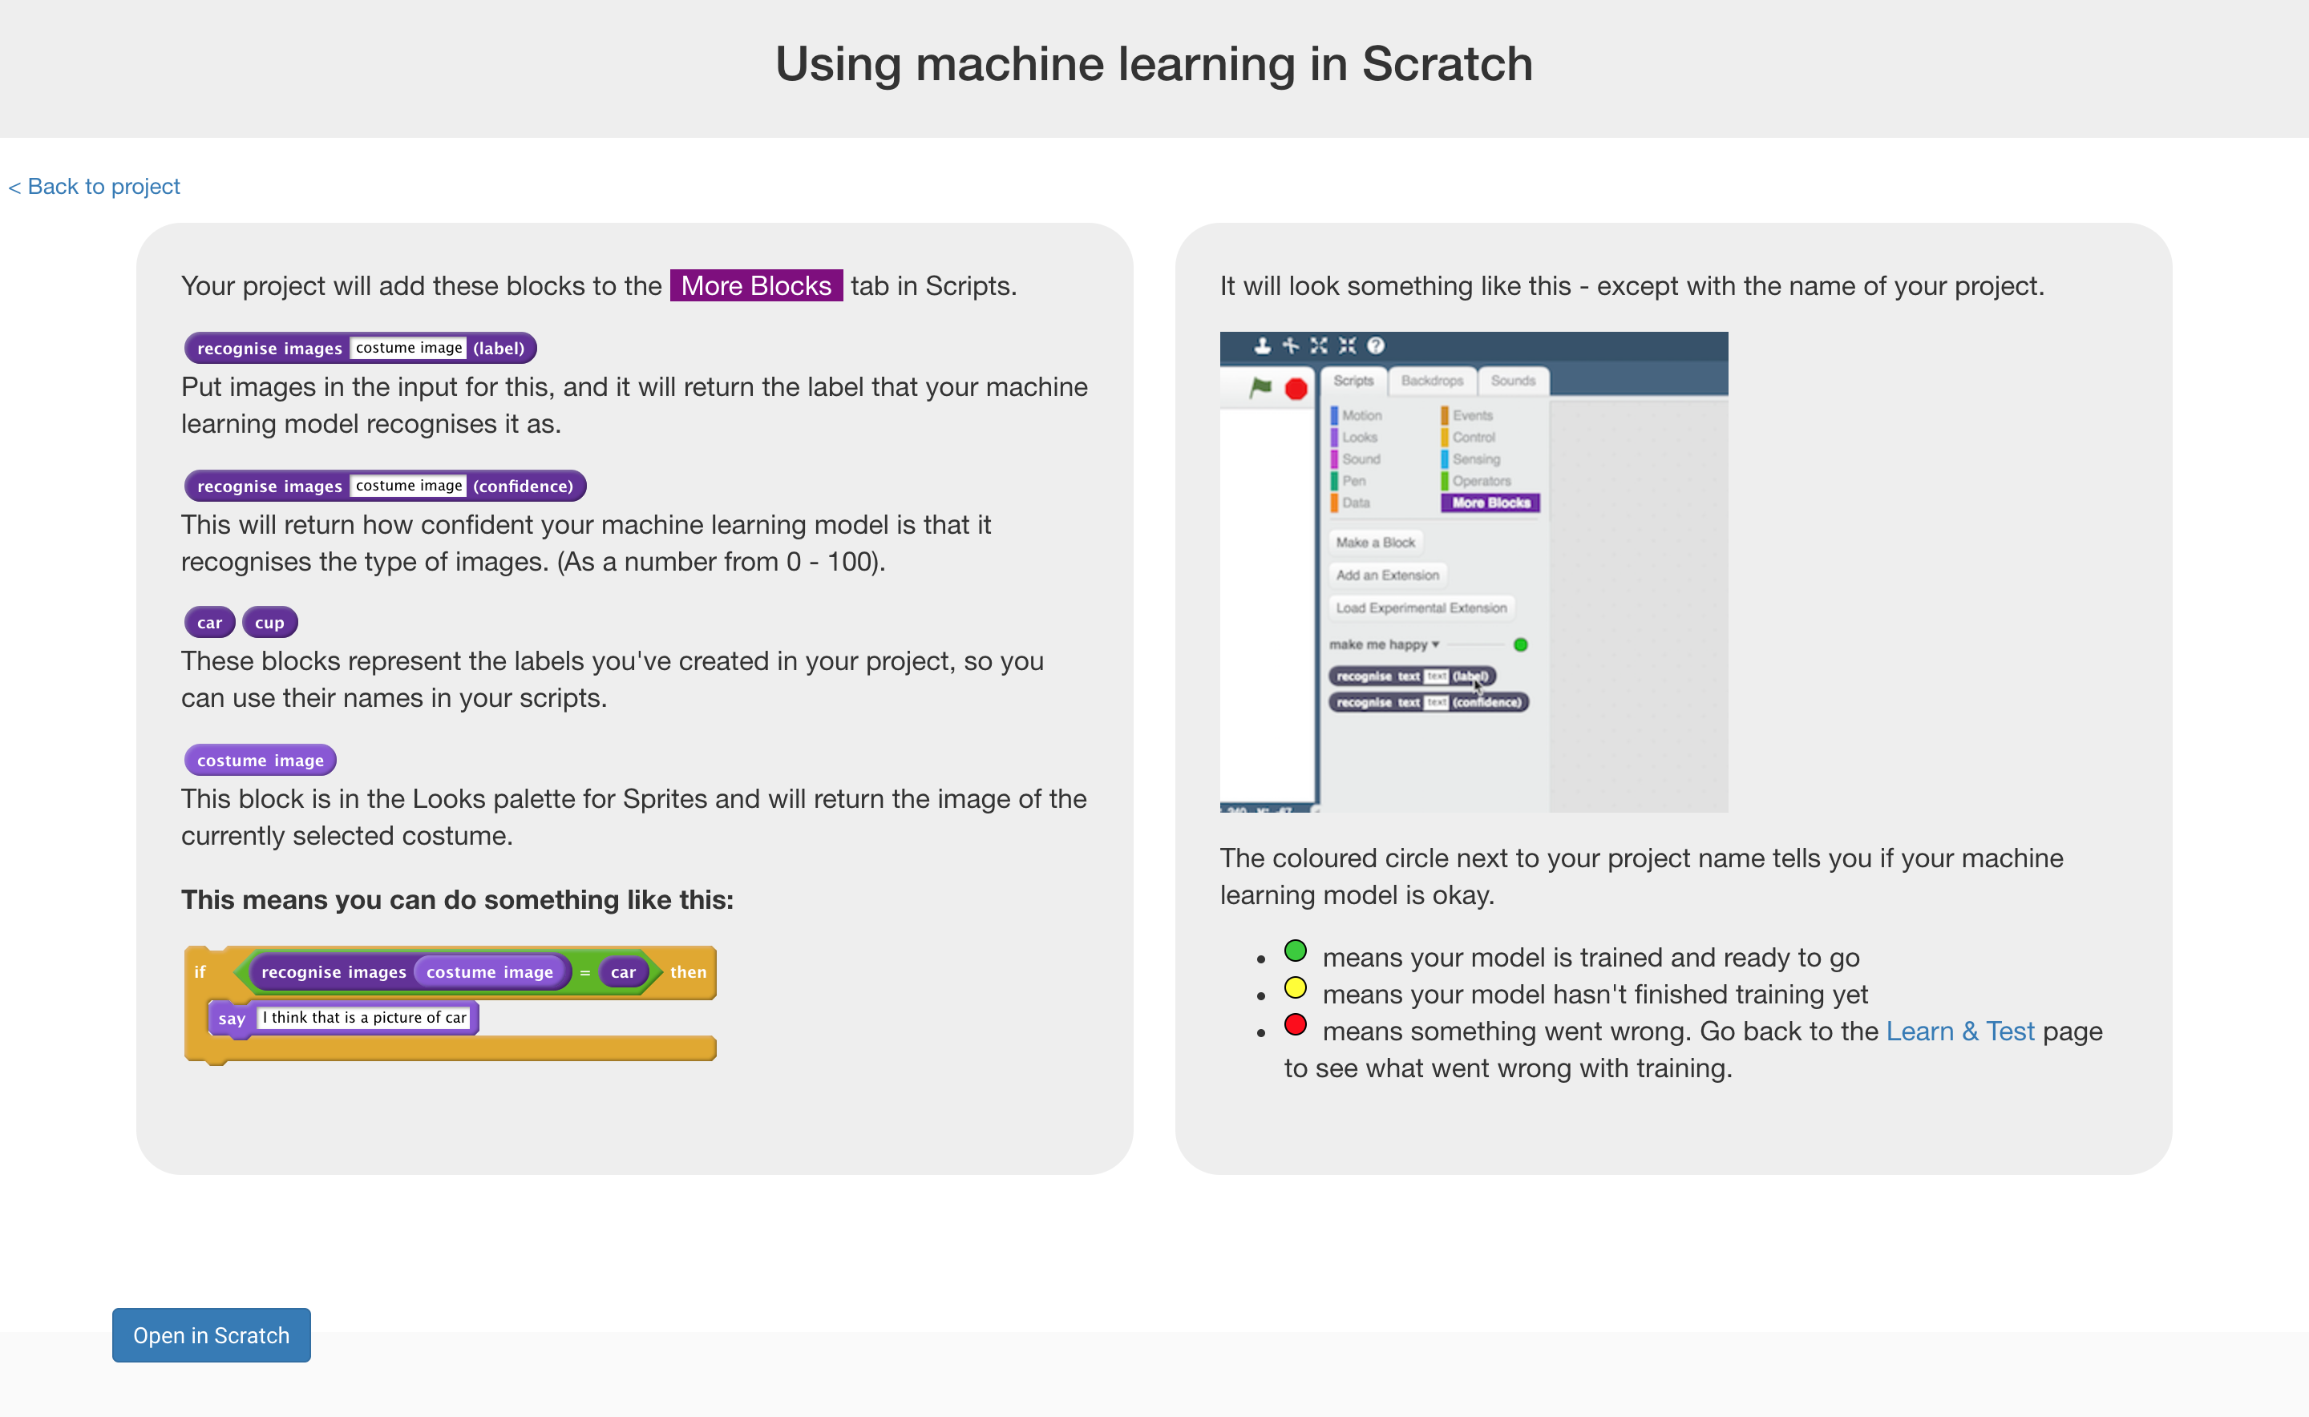

**到目前為止，你做了哪些事情？**

**What have you done so far?**

你已經開始訓練電腦分辨杯子和車子的照片，但你不是採用寫規則的方式來訓練，而是使用蒐集範例的方式。這些蒐集來的範例會被用來訓練一個機器學習的 『模型』。

You’ve started to train a computer to recognise pictures of cups and cars. Instead of trying to write rules to be able to do this, you are doing it by collecting examples. These examples are being used to train a machine learning “model”.

這就是所謂的『監督式學習』(supervised learning)，因為你給電腦訓練用的範例都確保是正確的，就像是在監督它一樣。

This is called “supervised learning” because of the way you are supervising the computer’s training.

電腦會從你給的範例照片中學習到一些模式，比方說形狀以及顏色的使用。這些東西會被用來辨識新的照片。

The computer will learn from patterns in the example photos you’ve chosen, such as the shapes and the use of colour. These will be used to be able to recognise new images.

1. 點選“**Open in Scratch**”按鈕來開啟Scratch

*你應該會在你的“car or cup” 專案中的『更多積木』(More blocks)區看到新積木*

Click the “**Open in Scratch**” button to launch the Scratch editor.   
*You should see new blocks in the “More blocks” section from your “car or cup” project.  
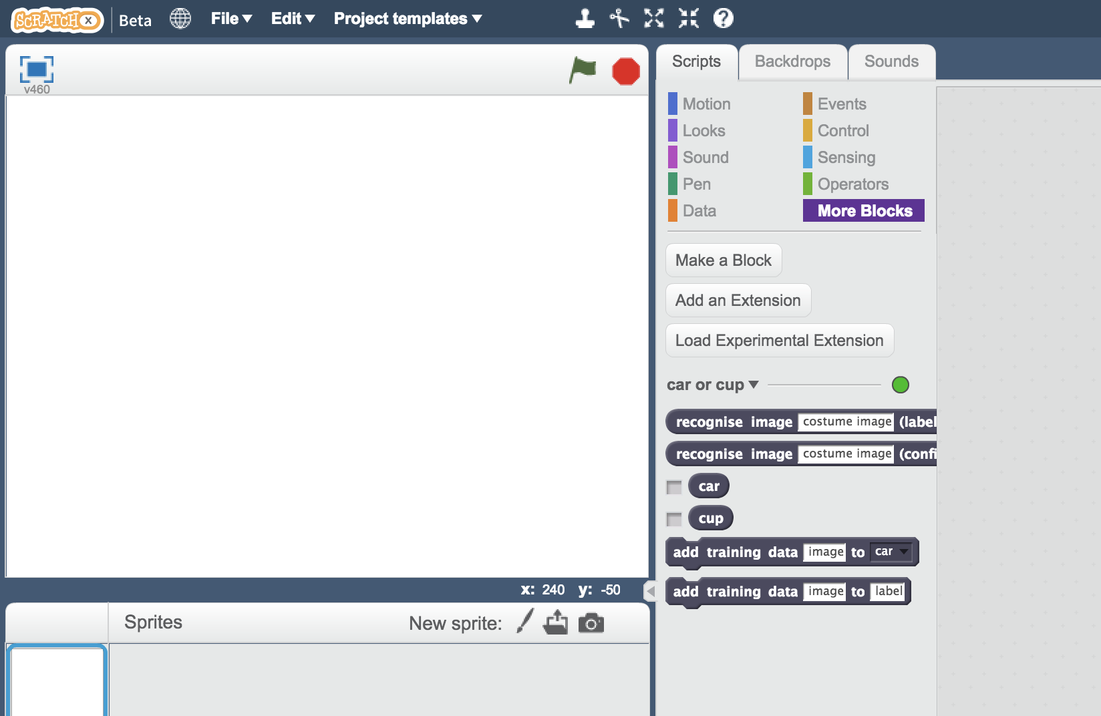*

1. 載入 **Car or cup 範本**

*如下圖所示，點選* ***Project template，再點選Car or cup***

Load the **Car or cup** template   
*Use* ***Project templates*** *->* ***Car or cup*** *as shown below.*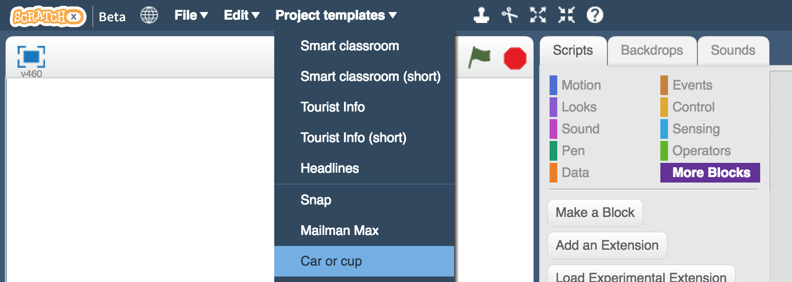

**小技巧**

**Tips**

**多一點範例！**

**More examples!**

當你給越多範例，電腦就應該能更正確的辨別出照片理的是車子還是杯子

The more examples you give it, the better the computer should get at recognising whether a photo is a cup or car.

**盡可能蒐集相同數量的照片**

**Try and be even**

**嘗試找到一樣多的車子和杯子的範例照片**

Try and come up with roughly the same number of examples for cups and cars.

如果你其中一種照片特別多，那麼電腦可能會更容易將照片判別成這一類，因此會影響到電腦辨識照片的學習

If you have a lot of examples for one type, and not the other, the computer might learn that type is more likely, so you’ll affect the way that it learns to recognise photos.

**確保範例中有各種圖片**

**Mix things up with your examples**

試著找到不同類別的範例

Try to come up with lots of different types of examples.

舉例來說，確保有不同背景的範例

For example, make sure that you include some examples with different backgrounds.

如果用來訓練電腦的每張車子照片都有草地，而且每張杯子照片都有木頭桌子的話，很有可能最後電腦學到的是辨識草地和木頭，而非車子和杯子  
If every photo of a car you use for training has grass in the background, and every photo of a cup you use for training is on a wooden table, you might end up training the computer to recognise grass or wood instead.

1. 點選綠旗並執行

*此專案中有數張隨機挑選的桌子或杯子照片。接下來你需要修改專案，讓電腦可以利用你先前給的訓練，將這些照片分類成二疊*

Click the **green flag** to give it a try.  
*The project has several random photos or cars or cups.   
Next you will modify the project to use the training you’ve given the computer, so that it can sort these photos into two piles.* 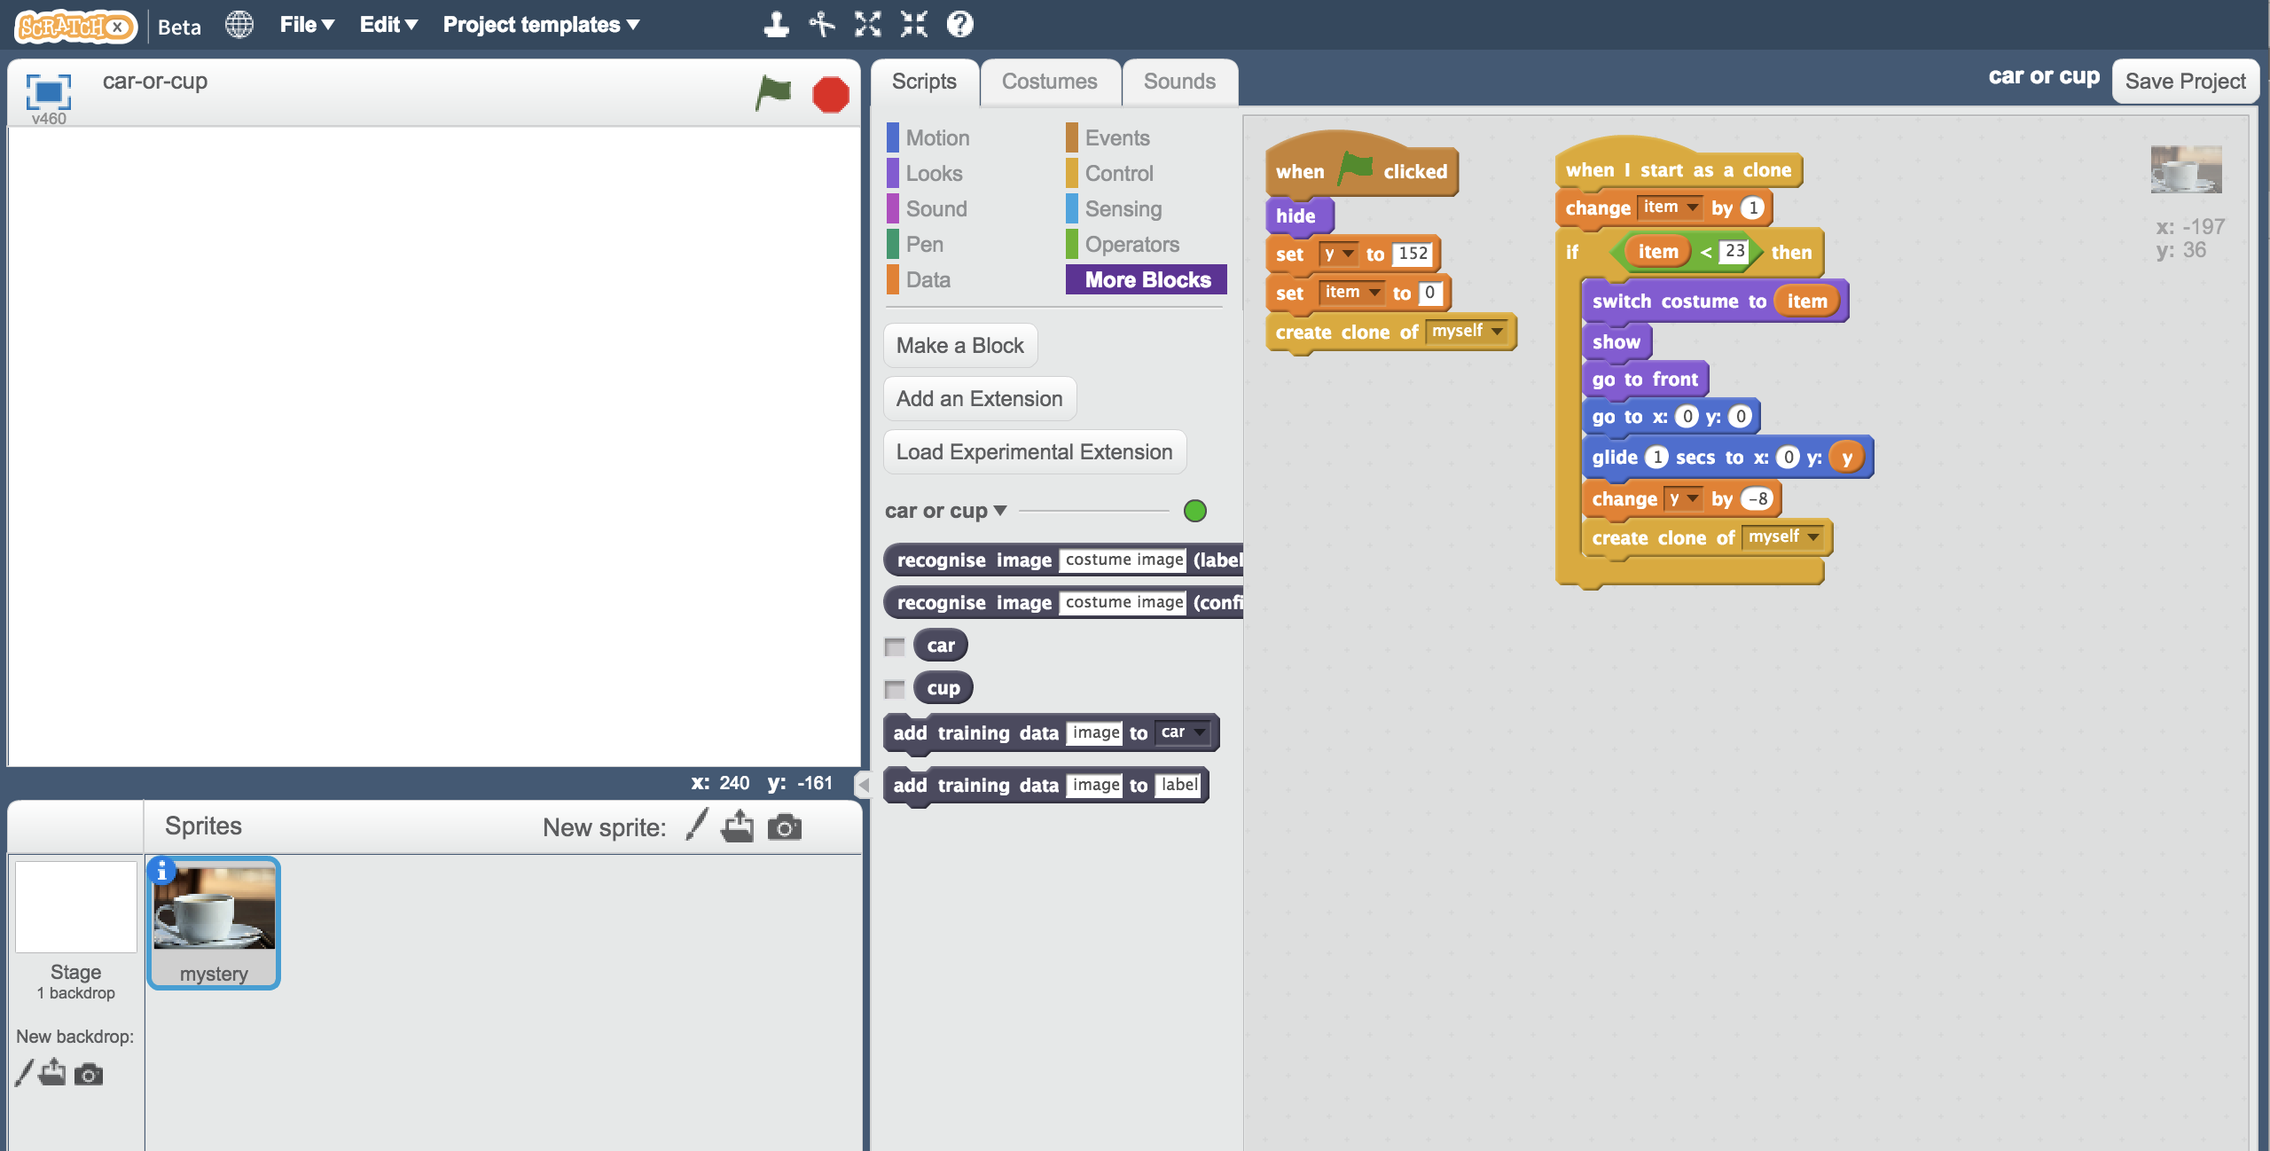

1. 點選角色“mystery”，點選『程式』(Scripts)，接著修改程式讓他可以使用你的機器學習模型

Click on the “mystery” sprite, and then click “**Scripts**” tab, and change the script to use your machine learning model.  
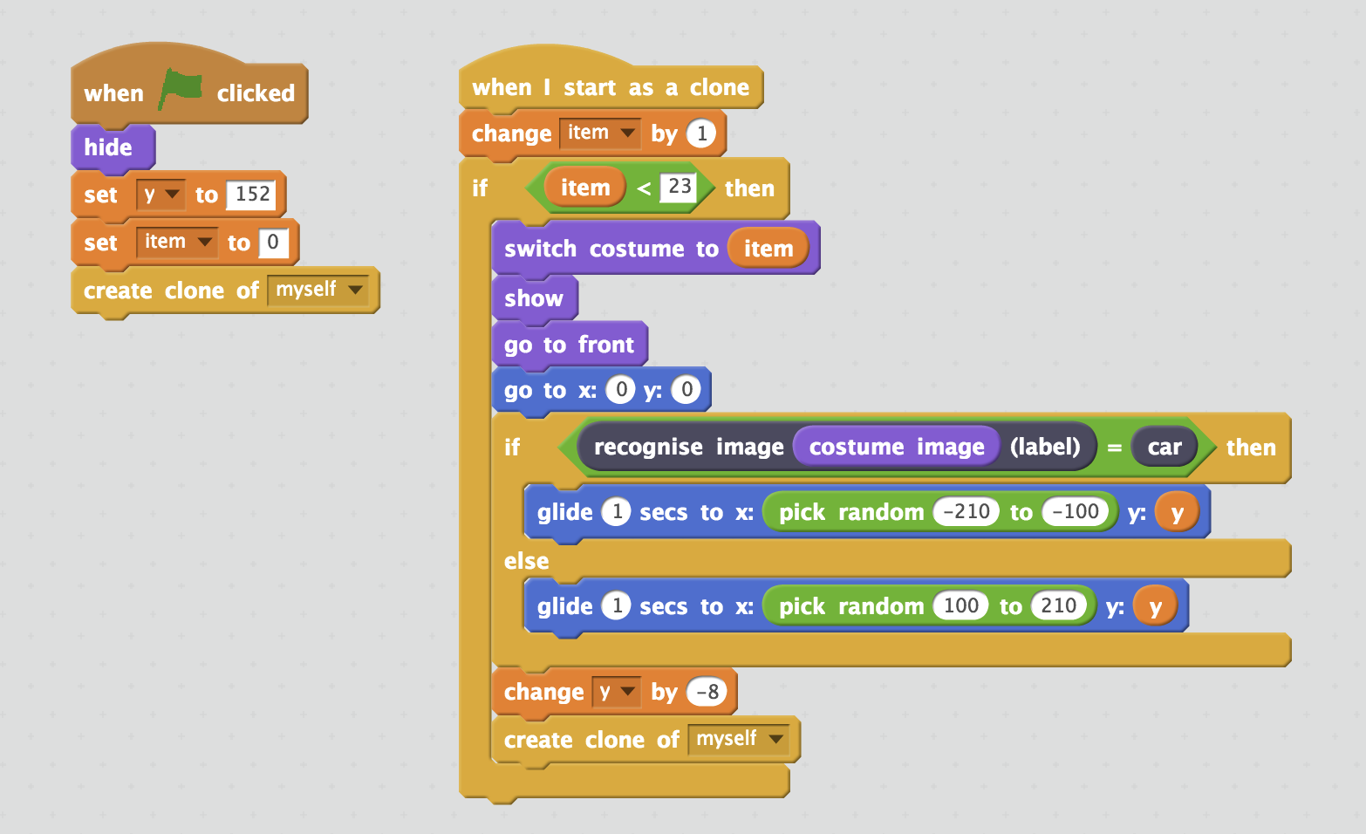

1. 點選全螢幕按鈕，再點選綠旗

Click the full screen icon, and then click the green flag

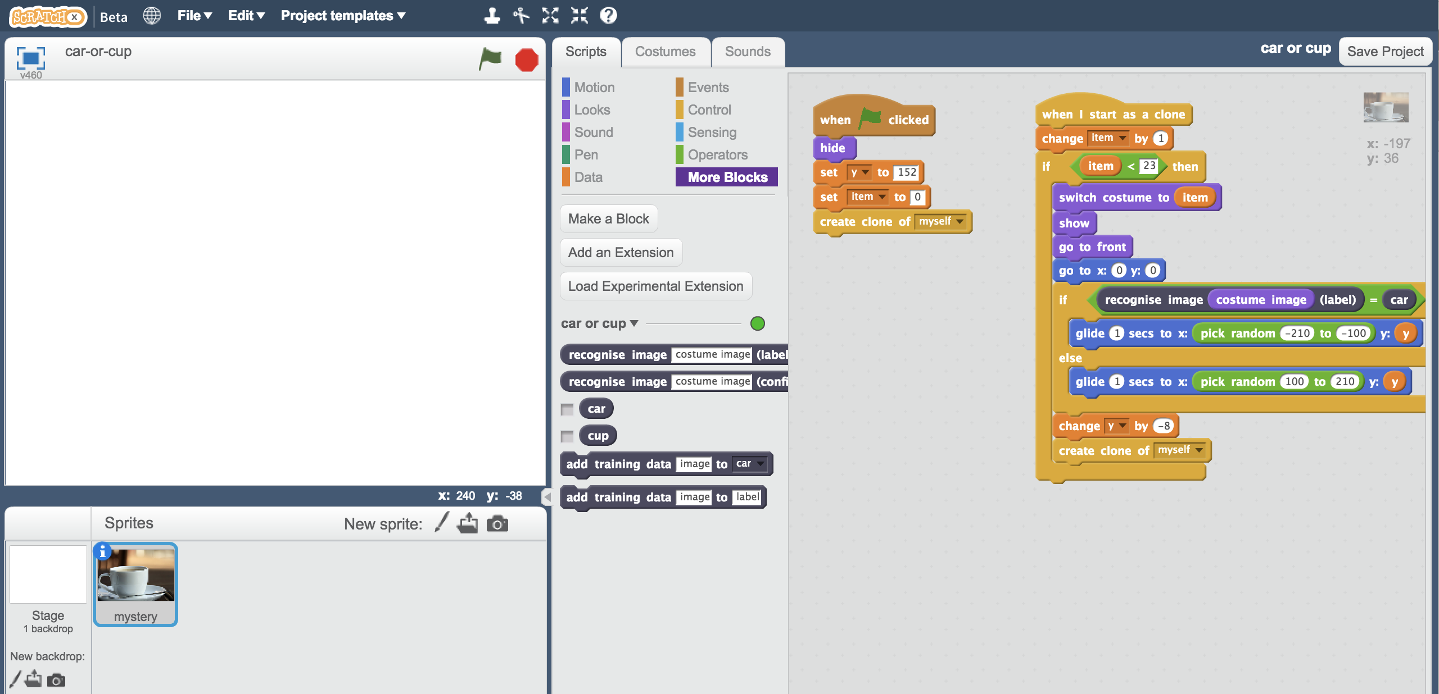

1. 觀察角色使用你們班所訓練出來的機器學習模型將一堆照片分成兩類

Watch your script use the machine learning model your class has trained to sort the photos into two piles.   
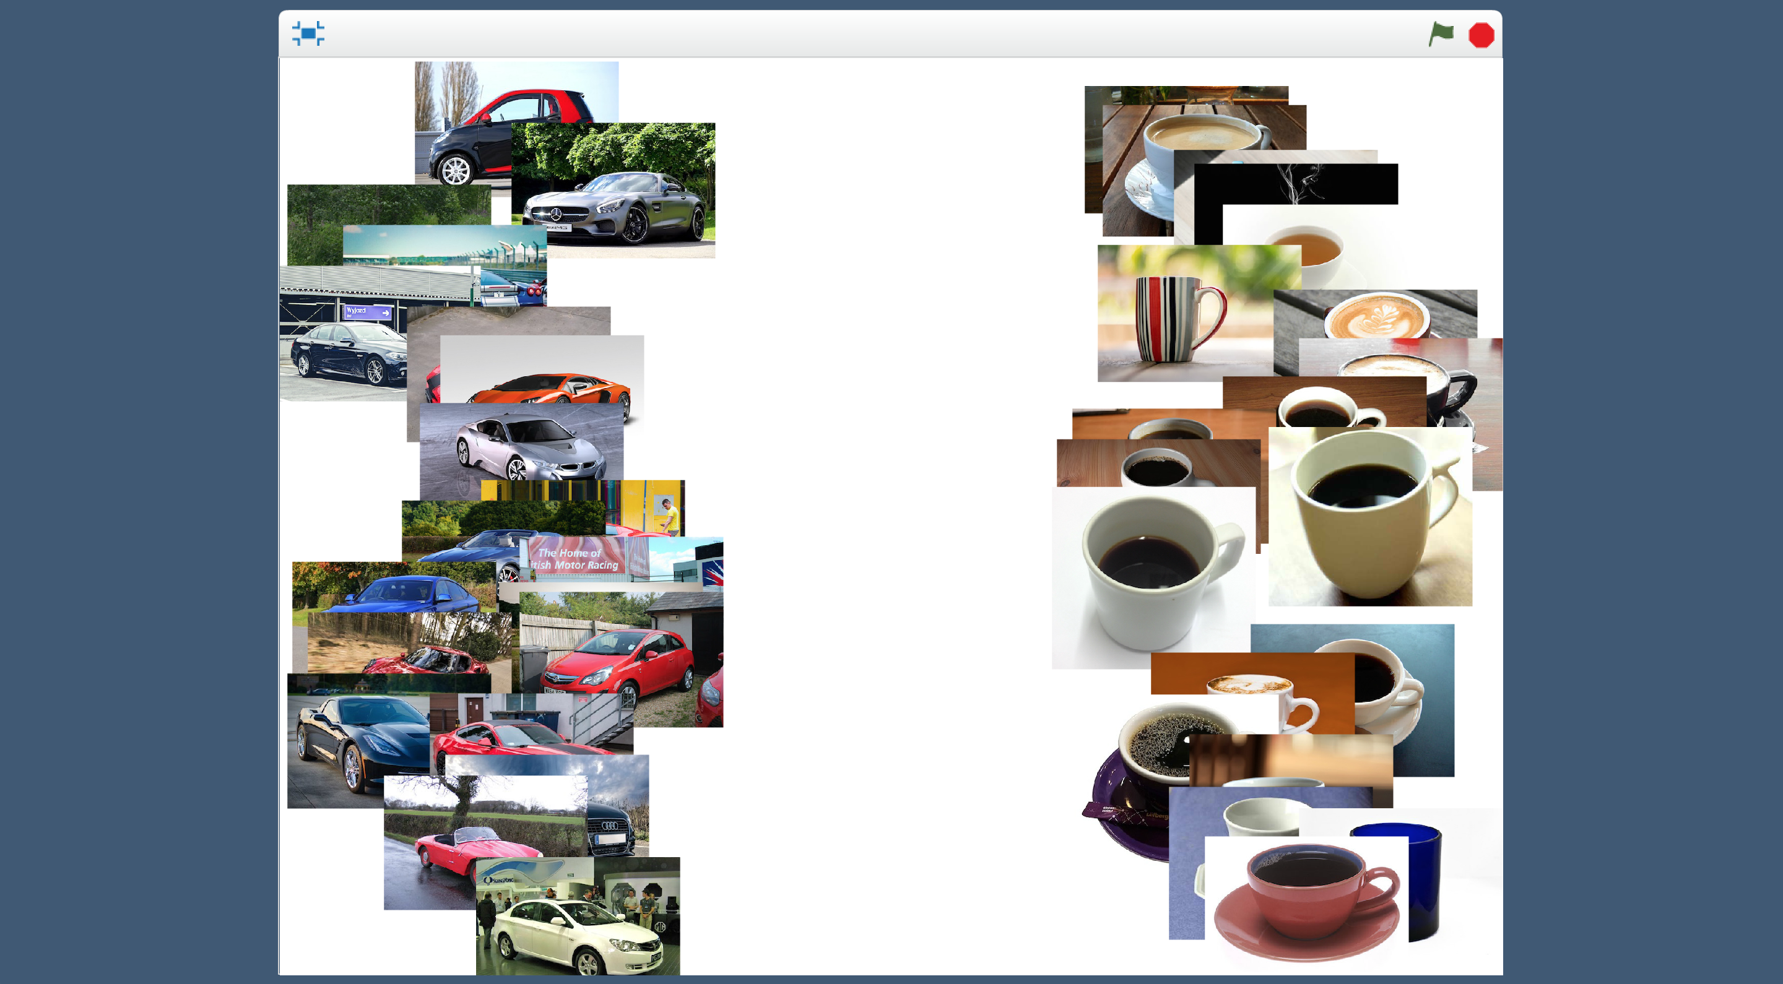

1. 存檔

*點選檔案，再點選儲存專案*

Save your project.  
*Click* ***File*** *->* ***Save project***

**你完成了什麼？**

**What have you done?**

你使用機器學習建立了一個照片自動分類器

You’ve used machine learning to build an automatic photo sorter.

訓練電腦可以自己辨別照片，會比手工分類數千張照片快得多

Training the computer to be able to recognise photos for itself is much much quicker than trying to sort thousands of photos manually.

而且當你給了越多範例，電腦辨識照片的正確率會越高

And the more examples you give it, the better it should get at recognising photos correctly.

**延伸活動**

**Ideas and Extensions**

現在你已經完成了這個專案，要不要試試下面的點子？或者，自己想一個？

Now that you’ve finished, why not give one of these ideas a try?

Or come up with one of your own?

**加入第三種類的相片**

**Add a third type of photo**

除了只辨識車子和杯子外，你能不能加入第三種類別？

Instead of just recognising cups and cars, can you add a third type as well?

**試著混淆電腦**

**Try confusing the computer**

使用10張以草地為背景的車子照片訓練電腦

使用10張以木頭桌子為背景的杯子照片訓練電腦

Train the computer to recognise cars with ten photos of a car on a grass background.

Train the computer to recognise cups with ten photos of a cup on a plain white background.

現在，試試電腦能否正確辨識出在純白背景的車子，或者是草地背景的杯子

Now see if the computer recognises a car on a plain white background.

Or if it can recognise a cup on a grass background.

電腦有被混淆了嗎？電腦是否有學習到如何辨別杯子和車子？還是被背景影響了？

Does the computer get confused? Did it learn to recognise the cup and car? Or was it more influenced by the background?

嘗試找出電腦是如何學習，以及如何表現

Experiment to find out how the computer learns, and how it behaves.